1. 請各位同學設計一三位元加/減法器，並將電路繪製出。(同學可手繪，但請拍照或掃描後再上傳)

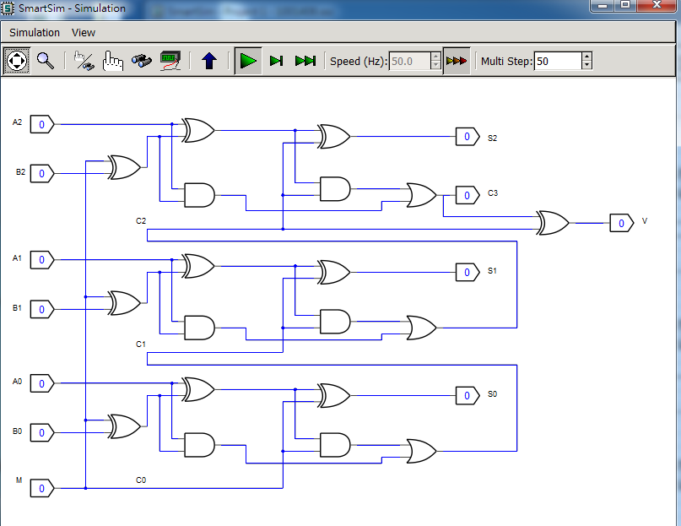

1. 說明三位元加/減法器之工作原理及真值表。

功能：M=0:A+B; M=1:A-B, M=0時是加法,M=1時是減法,利用最後output的XOR來做類似Inverter 的功能。

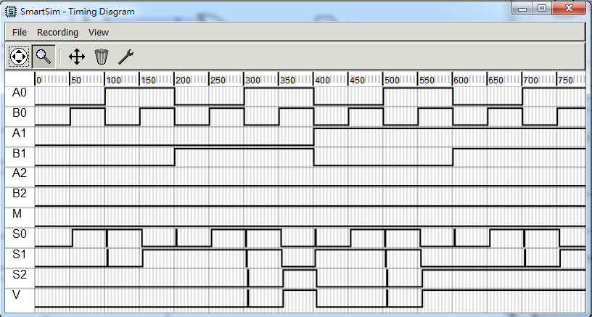

(總共有2^7可能，下列為M=0加法的情況, 顯示部分Truth table)

|  |  |  |  |  |  |  |  |  |  |
| --- | --- | --- | --- | --- | --- | --- | --- | --- | --- |
| A0 | B0 | A1 | B1 | A2 | B2 | M | S0 | S1 | S2 |
| 0 | 0 | 0 | 0 | 0 | 0 | 0 | 0 | 0 | 0 |
| 0 | 0 | 0 | 0 | 0 | 1 | 0 | 1 | 0 | 0 |
| 0 | 0 | 0 | 0 | 1 | 0 | 0 | 1 | 0 | 0 |
| 0 | 0 | 0 | 0 | 1 | 1 | 0 | 0 | 1 | 0 |
| 0 | 0 | 0 | 1 | 0 | 0 | 0 | 0 | 1 | 0 |
| 0 | 0 | 0 | 1 | 0 | 1 | 0 | 1 | 1 | 0 |
| 0 | 0 | 0 | 1 | 1 | 0 | 0 | 1 | 1 | 0 |
| 0 | 0 | 0 | 1 | 1 | 1 | 0 | 0 | 0 | 1 |

|  |
| --- |
| V |
| 0 |
| 0 |
| 0 |
| 0 |
| 0 |
| 0 |
| 0 |
| 1 |